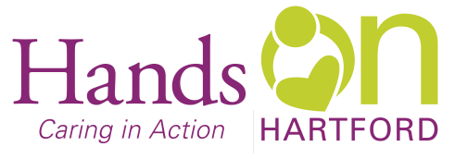

**Peer Support Specialist**

**Wanted**: Versatile energetic individual to join our team at Hands On Hartford as a **Part Time Peer Support Specialist.** Using their own past or present experience of homelessness and/or recovery, they will play an active role in engaging individuals who are currently experiencing homelessness.

**Why work at Hands On Hartford**: Hands On Hartford, located in the vibrant Parkville neighborhood of Hartford in partnership with others, strengthens community in Hartford by responding faithfully to people in need through programs that change lives and renew human possibility. We’re a 54-year-old nonprofit that values diversity, team work, and takes a strengths-based, collaborative approach to all we do.

**When:** 16 hours a week that includes days, evenings and weekends. Flexibility in the work schedule is expected for meetings, trainings and events. Schedule subject to change based on the needs of the program and agency.

**Pay:** Range $16-$19 per hour

**As a Peer Support Specialist: You will do many things including but not limited to:**

* As a part of the outreach team, canvass streets, woods, and other areas identified as places where unsheltered people are living.
* Utilize own expertise with homelessness to provide individualized, ongoing guidance, coaching, support, and inspiration.
* Provide education in the use of personal and community resources to identified individuals.
* Assist in developing formal and informal community supports.
* Assist the individual served in increasing social support networks of relatives, friends and/or significant others.
* Advocate on behalf of the persons with behavioral health and/or substance use challenges to protect the client’s rights and to assist in reducing associated stigma.
* Connect individual to community providers.
* Participate in collaborative team coordinating huddles and meetings.
* Enter client information into data management system, including but not limited to intakes and progress notes.
* Keep a log of all toiletry, clothing, bus passes and other resources given out during outreach.
* Maintain any additional client records as required by funder.
* Have a valid driver’s license, registered and insured motor vehicle and ability to lift and carry at least 25 pounds.
* Fluency in Spanish and English preferred.

**Work Schedule and Benefits**

* Dedicated, diverse, and friendly co‐workers
* Paid time off – 12 holidays, +vacation, +personal time, + sick leave
* 401(k) employer contribution and employer match
* Free on-site parking

**If this sounds like a good fit to you:**

**Send letter of interest & resume to: Stephanie Boyce, Director of Homeless Prevention, Outreach,**

**and Food Access**

**Hands On Hartford, 55 Bartholomew Ave, Hartford CT 06106.**

**Email sboyce@handsonhartford.org**

**AA/EOE**