ADVOCACY UNLIMITED, INC.
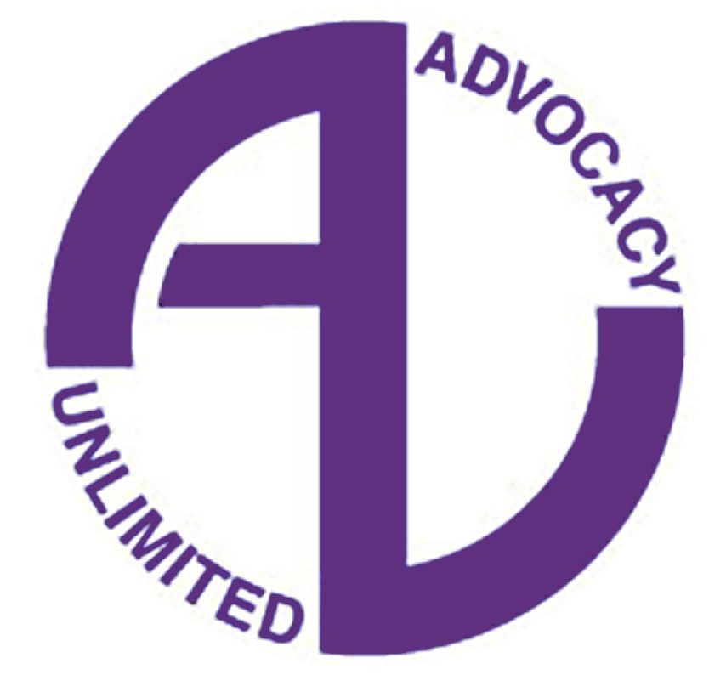
Join Rise Be | Part-time Warmline Operator

POSITION DESCRIPTION:
Join Rise Be (JRB) is peer-run emerging adult initiative that operates through Advocacy Unlimited, Inc. JRB is dedicated to making the opportunity of recovery available to all young people across the state of Connecticut. We achieve this vision through sharing our experience to influence policy and practice, demonstrating the positive outcomes of recovery, and encouraging recovery during the transition to adulthood through self-exploration and personal growth. One operation of JRB is the Statewide Young Adult Warmline, which is a phone-based peer support line for young adults who are seeking resources as they navigate challenges and figure out who they are. The position of Join Rise Be (JRB) Part-Time Warmline Operator will carry out phone based peer support and digital and community outreach. Staff members are responsible for the sustainability and growth of the JRB Initiative. To learn more about Join Rise Be, please go to www.joinrisebe.org.

PART-TIME NON-EXEMPT EMPLOYMENT: 18 Regularly Scheduled Hours per week

ESSENTIAL JOB DUTIES:
Phone-Based Peer Support
• Provide active listening and mutual support to people calling the Warmline
• Offer referrals and information on community resources to callers
• Complete online call-log after each call
• Review and understand Warmline training material
• Contribute to digital outreach as defined in the social media guidelines
• Facilitate community presentations and workshops, as needed
• Develop and maintain communication with community partnerships
• Attend JRB staff meetings
• Create spaces for people to be seen, heard, and valued

EDUCATION & EXPERIENCE:
Recovery Support Specialist, preferred.
High School Diploma or equivalent.
Experience with mental health and/or addiction challenges.

REQUIRED SKILLS AND ABILITIES: Recovery-oriented, flexible, culturally sensitive, and a team player. Ability to work independently. Basic understanding of Microsoft Office. Ability to conduct internet searches. Proficient communication skills, both written and verbal. Public speaking, preferred. Engagement with current social media platforms and relevancy with generational and developmental trends related to emerging adulthood.

